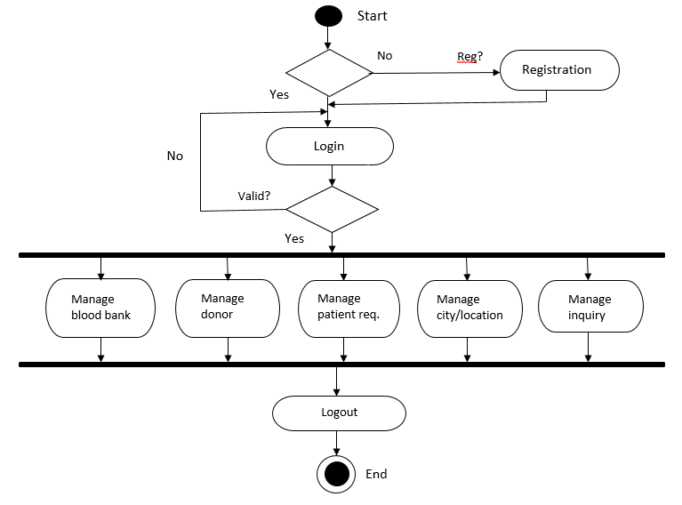

Start

End

Yes

Valid?

No

Yes

Reg?

No

Registration

Logout

Manage blood bank

Manage donor

Manage patient req.

Manage city/location

Manage inquiry

Login